Plant Disease Diagnostic Clinic
Plant Pathology and Plant-Microbe Biology Section
329 Plant Science Building Ithaca, NY 14853‐5904
Basil Diseases: Various
Introduction
Basil is a popular herb prized for its flavorful foliage, mostly in cooking. Basils can be easily grown indoors and out in the garden. However, there are several diseases that could cause damage leading to yield lost, especially under high humidity to which basil is very sensitive. Very few pesticides and fungicides have been registered for use on basil. Llearning about the common basil diseases and preventing them by cultural practices such as maintaining good air circulation and good field sanitation coupled with using tested seeds of tolerant or resistant varieties are the best way to control basil diseases.

Fusarium wilt (Fusarium oxysporum f. sp. basilicum) is one of the most common basil diseases. Other destructive diseases include bacterial leaf spot (Pseudomonas cichorii), gray mold (Botrytis cinerea) and damping off or root rot (Rhizoctonia solani; Pythium spp.). Moreover, although downy mildew (Peronospora belbahrii) is relatively new in North America, it is also very destructive, and widespread occurrence can happen if it is uncontrolled. Last but not least, the symptoms of nutrient deficiency might be caused by root – knot nematode which also can infect basil.
Figures 1 and 2: Symptoms on the underside of a basil leaf may look like soil is attached to the leaf (above)or appear as a thin fuzzy gray layer (below) (provided by S. Jensen, Cornell University)

Symptoms and Signs
Downy mildew: An initial symptom is yellowing of leaves, typically from around the middle vein and then spreading to most of the leaf surface. As the disease progresses, the more characteristic symptom of fuzzy grayish-purple sporangia (the reproductive structures) develop on the lower surface of the leaves. Initially, this may look like a fine layer of dirt sticking to the undersurface of the leaf, but under magnification, the sporangia can be seen and used for diagnostic purpose. If the humidity remains high, the chlorotic lesions quickly turn brown.
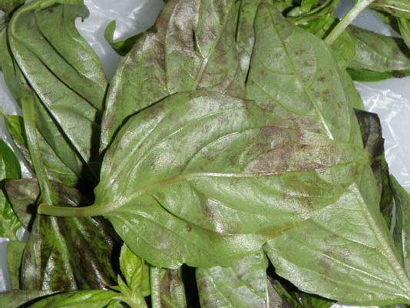
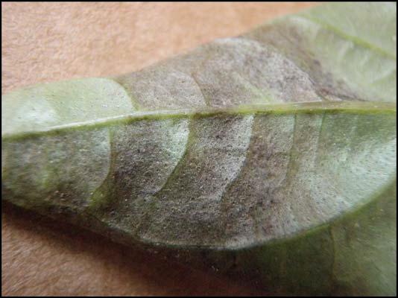

Fusarium wilt: Stunted and wilted plants with yellowish leaves are the initial symptoms that may develop when the plants are 6-12 inches tall. Before this stage, the symptoms are not clear and infected plants may grow normally. Brown streaks on the stems, discoloration of stem tissue, severely twisted stems and eventually sudden leaf drop are common symptoms in the late stage of disease development. Sweet basil is more severely affected than other basil varieties.
Bacterial leaf spot/Basil shoot blight: Typical symptoms are the water-soaked brown and black spots on leaves and streaking on the stems. The leaf spots are angular or irregular or delineated by the small veins. This disease might be not severe under field conditions, but it can be devastating to seedling production.
Gray mold: The most characteristic symptoms are a brown to gray fungal growth on both leaves and stems. This growth usually appears as a denser/fuzzier mold than downy mildew. Diseased leaves die and eventually fall from the plant. If severe lesions develop on main stem, the infected plant may die.
Damping off/Root rot: Damping off happens in the seedling stage when plants collapse after germinating. The pathogen often infects the base of seedlings, causing shriveling of the stem. For root rot, typical symptoms are the slow or sudden wilting leading to plant collapse because the roots are dead or too damaged to function properly.
Root-knot nematode: Foliar symptoms are similar to nutrient deficiency symptoms including wilting, discoloring and low yield. Examination of root may show variable size swellings (galls).
Disease Cycle
Downy mildew: The disease is most likely introduced and spread through contaminated seeds, infected leaves on the market and wind-dispersed spores (Infected basil leaves can produce lots of spores which could be dispersed long distance). Moderate to warm temperatures and high humidity are favorable conditions for the disease development.

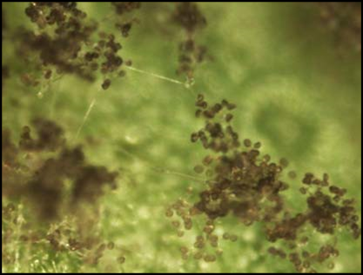
Figure 3: Close-up of sporangia on the underside of a leaf with downy mildew (provided by S. Jensen, Cornell University).
Fusarium wilt: This devastating fungal disease is caused by a soil borne pathogen and may be introduced into the field or spread by contaminated seeds or movement of soil where infected plants have been growing. Once established, the fungus can overwinter and survive for many years as spores and cause new infections if basil or other members of the mint family are re-planted.
Bacterial leaf spot/Basil shoot blight: The causal bacteria are reported to be first introduced to new fields from contaminated seeds and transplants. Disease is favored by humid conditions and is spread by splashing water carrying bacteria from the infected soil to plant tissues or by touching plants after handling infected tissues.
Gray mold: Poor air conditions, high humidity and moderately cool temperatures are the favorable conditions for this disease. Infections are more likely to invade wounds and then spread to leaves and secondary buds. When they reach the main stems, the entire plant is killed. Infected leaves and stems produce abundant mycelium covered with conidia that are easily spread by handling, splashing water or touching diseased and nearby healthy plants. If the conditions favorable for gray mold are prolonged, this disease can through the entire planting.
Root rot/damping off: High humidity and poor air circulation are also the favorable conditions for these problems.
Root-knot nematode: Nematodes are soil-borne microscopic roundworms that damage the roots. Once established in soil, it is hard to eradicate this pathogen from contaminated soil.
Management Strategies
Downy mildew: Few fungicides are specifically labeled for this disease which is being found more frequently in the Northeastern U.S. management practices include planting tested seed, growing tolerant varieties and applying fungicides frequently (when possible) and before the first symptoms appear. In greenhouses, minimizing humidity, circulating the air, increasing space between plants, and using drip irrigation may also help. In the field or garden, good sanitation practices should be used to minimize inoculum levels.
Many of the same management practices apply for the other common diseases of basil. Where possible, use tested or treated seed or buy only healthy transplants. Once established, bacterial leaf spot, Fusarium wilt and gray mold may be more difficult to manage as few if any effective fungicides may be available. Use good sanitation practices in both garden or greenhouse sites to minimize inoculum levels. Increasing space between plants/providing good air circulation, limiting splashing water, and irrigating at the base of plants to avoid wetting leaves may also be helpful. Where feasible, remove diseased leaves or severely infected plants to help minimize the available inoculum. If Fusarium wilt becomes established in a field, crop rotation with plants other than basil or minimum for 2-3 years can also help reducing future infections.
Root rot/damping off: For greenhouse, using sterile soil and clean pots to help reduce these problems and avoid over-watering.
Root-knot nematode: Prevention is the best practice. Crop rotating is not very effective because these nematodes have a wide host range. Applying organic matter to the soil and soil solarization have been shown to be helpful.

References
- Expect and Prepare for Downy Mildew in Basil. M. M. McGrath. Vegetable MD Online News Article.

- Leaf spot and blight of basil, Ocimum basilicum caused by Pseudomonas cichorii. Burgess S. M., Lawson B. O., Miller W. J., 1986. Pro. Fla. State Hort. Soc. 99: 249-251.

- What you should know about the pests and diseases of basil. Johnny’s Selected Seeds: # 8660.

- First Report of Basil Leaf Spot Caused by Pseudomonas cichorii in Louisiana and Cultivar Screening Results. G.E. Holcomb and P. J. Cox.

- 2009 Florida Plant Disease Management Guide: Sweet Basil. Shoan Zhang and Pamela D. Roberts

- Epidemiology of Botrytis cinerea in Sweet Basil and Implications for Disease Management, Ct Agric. Exp. Station.

- Basil Problem: Fusarium wilt. Growing Small Farms: Chatham County Center, North Carolina Cooperative Extension. 2005

- Basil Problem: Bacterial Leaf Spot (Pseudomonas cichorii). Growing Small Farms: Chatham County Center, North Carolina Cooperation Extension. 2003.

Prepared by Tien Tran, May 2011, Updated by SLJ April 2024
READ THE LABEL BEFORE APPLYING ANY PESTICIDE! Changes in pesticide regulations occur constantly. All pesticides distributed, sold, and/or applied in New York State must be registered with the New York State Department of Environmental Conservation (DEC). Questions concerning the legality and/or registration status for pesticide use in New York State should be directed to the appropriate Cornell Cooperative Extension Specialist or your regional DEC office.

The Cornell Plant Disease Diagnostic Clinic
Phone: 607‐255‐7850
Fax: 607‐255‐4471
Email: mailto:Cornell-plantdiseaseclinic@cornell.edu
Web: plantclinic.cornell.edu

