Plant Disease Diagnostic Clinic
Plant Pathology and Plant-Microbe Biology Section
329 Plant Science Building Ithaca, NY 14853‐5904

Tomato Virus Diseases: Various

Introduction
Fresh tomatoes are a hallmark of summer and a staple in many home gardens. Identification and management of tomato diseases is an important step in obtaining a successful tomato harvest. Viral diseases can negatively affect tomatoes by drastically reducing yield and/or fruit quality. This fact sheet highlights 3 viral diseases of tomato that are commonly encountered by home gardeners: Cucumber Mosaic Virus (CMV), Tobacco Mosaic Virus (TMV) and Tomato Spotted Wilt Virus (TSWV). Information designed to aid in diagnosis and management of these viral diseases is provided.

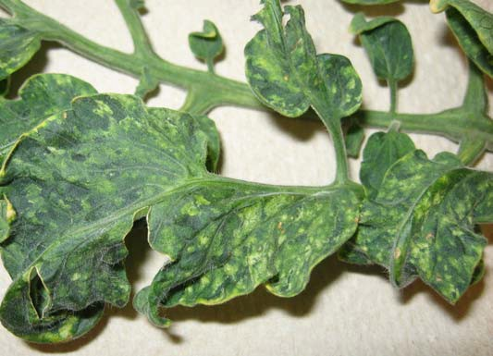
Common virus mosaic symptoms. Plant shown was infected with Tomato Mosaic Virus (ToMV) or Tobacco Mosaic Virus (TMV).

Symptoms and Signs
Cucumber Mosaic Virus is one of the most widespread of all viral diseases. It is particularly damaging to home gardens because it infects many other familiar vegetables (e.g. carrot, cucurbits, Geranium, Petunia, Zinnia). These alternate hosts may serve as a source of inoculum for tomato infection. Symptoms on tomato may vary depending on severity and time of infection but typically include plant stunting and yellowing and/or mottling of leaves. The most characteristic feature of this disease is wrinkling of leaves such that stems appear prominent, forming a ‘shoestring’ appearance.
Tobacco Mosaic and Tomato Mosaic Viruses are closely related viruses causing similar symptoms and so will be covered together. These viruses are common in home gardens, affecting a number of flowers, weeds, and vegetables such as tomato, pepper, and eggplant. Infected tomato plants are characterized by a light- and dark-green mottling and possibly upward curling and malformation of
leaves. Mottling is best viewed by partially shading a leaf. Other symptoms may include plant stunting, uneven fruit ripening, and reduced fruit set. Diagnosis of this disease is particularly difficult because symptom expression can vary depending on virus strain, tomato cultivar, time of infection, and environmental conditions.
Tomato Spotted Wilt Virus, like the other common viral diseases, can infect a large number of ornamental, weed, and vegetable species. Its cosmopolitan nature makes it a frequent disease problem in greenhouses as well as home gardens. It can be particularly devastating to tomato, where it causes bronzing and spotting of young leaves, dark streaks on stems, and brown shoot tips. Young fruit often appear mottled and develop light-colored concentric rings. Mature fruit exhibit large white or yellow blotches that make them unmarketable.

Disease Cycle
Cucumber Mosaic Virus on tomato is not seed transmitted and typically enters a home garden on infected transplants or from weedy hosts of the virus. It is non-persistently transmitted by a number of aphid species, so even a brief feeding episode is sufficient for virus transmission. Thus aphid transmission often occurs without direct observation of aphid presence.
Tobacco Mosaic and Tomato Mosaic Viruses are extremely stable and can survive for years in soil, plant debris, and even on clothing. It is transferred between plants almost exclusively by human activity (i.e. watering, pruning, transplanting). It is also seed transmitted, however, so the progeny of infected plants may also be infected.
Tomato Spotted Wilt Virus is vectored persistently by thrips. Thrips acquire the virus exclusively as larvae and are then able to transmit the virus for the remainder of their lives. Virus sources for primary infection typically include perennial ornamentals and weeds. This virus is likely to enter a home garden by the planting of infected seeds or transplants or from feeding by infected thrips.
Management Strategies
For seed-transmitted viruses it is important to obtain clean seed. This can be assured by purchasing seed from reputable vendors, exposing dry seed to high temperature (70°C.) for 2-4 days, and/or by treating seeds with 10% Trisodium Phosphate for at least 15 minutes. Whenever possible, virus resistant tomatoes should be planted. Additionally, removal of symptomatic plants may slow the spread of disease once it occurs.

References
Vegetable MD Online web site: (http://vegetablemdonline.ppath.cornell.edu/) in 2007. The Vegetable MD Online web site been retired, and some fact sheets have been moved to: Disease factsheets and articles | Cornell Vegetables.
Compendium of Tomato Diseases. 1991. Jones, J. P., Stall, R., and Zitter, T. APS Press. St Paul, MN.
Identifying Diseases of Vegetables. 1983. MacNaab, A., Sherf, A., and Springer, J. The Pennsylvania State University, University Park, PA.
A Colour Atlas of Tomato Diseases - Observation, Identification and Control. 1994. Blancard, D. Manson Publishing Ltd., London
Prepared by Jason Cavatorta, May 2007; Updated SLJ2 March 2024
READ THE LABEL BEFORE APPLYING ANY PESTICIDE! Changes in pesticide regulations occur constantly. All pesticides distributed, sold, and/or applied in New York State must be registered with the New York State Department of Environmental Conservation (DEC). Questions concerning the legality and/or registration status for pesticide use in New York State should be directed to the appropriate Cornell Cooperative Extension Specialist or your regional DEC office.

The Cornell Plant Disease Diagnostic Clinic
Phone: 607‐255‐7850
Fax: 607‐255‐4471
Email: mailto:Cornell-plantdiseaseclinic@cornell.edu
Web: plantclinic.cornell.edu

