

Plant Disease Diagnostic Clinic

Plant Pathology and Plant-Microbe Biology Section  
329 Plant Science Building Ithaca, NY 14853‐5904

**Bark Splitting on Trees:** *Various*

**Introduction**

Bark splitting can occur in response to various environmental factors at different times of the year. Splits can occur on the trunk of the tree as well as on branches. Trees which are most susceptible to this type of injury are those which are thin barked, such as certain fruit trees. Newly planted trees or young trees are more prone to bark-splitting. Bark splits are not likely to be fatal to trees, although they will, in some cases, allow entry of disease organisms which can cause decay. Through proper treatment to encourage the natural callusing process, a tree should be able to close most splits.

Figure 1: Bark Split on Kwanzan Cherry

There is no single reason for bark splitting on trees. During late winter and early spring, severe cold followed by rapid thawing can result in splits referred to as "frost cracks". These frost cracks can start from a wound inflicted earlier in the tree's development. Sometimes the crack may remain in the internal wood, but frosts can cause the crack to

expand and split the bark. Excessively late growth in the fall stimulated by warm temperatures, high humidity, and high nitrogen levels can increase the susceptibility of trees to frost cracking.

Fluctuating growth conditions may also cause splitting of bark. Dry weather (which slows growth) followed by wet or ideal growth conditions may cause an excessive or vigorous amount of growth leading to splits in the bark.

**Symptoms and Signs**

Sunscald, especially in winter months, can cause bark injury to thin-barked or young trees. Although an exact split may not be seen immediately, the outer layer of bark will peel away from the affected area in the summer following the winter damage. Sunscald injuries to tree limbs can be minimized by avoiding heavy pruning of trees with dense canopies. Gradual thinning of limbs over a period of years is preferable, particularly on thin-barked trees. Newly planted trees may be protected from sunscald by wrapping main trunks with tree wrap.

As mentioned before, certain trees are more susceptible to splits than others. The trees for which we receive the most inquiries concerning splits are Kwanzan cherry (Fig. 1), maple, and fruit trees. Any newly planted tree, especially of a thin-barked species, is a candidate for bark-splitting if it is not cared for properly. Be particularly careful to avoid fertilizing the trees late in the growing season, as this may promote new growth and predispose the tissue to winter injuries (including bark splitting). Autumn fertilization following leaf drop and dormancy should not lead to this problem.

**Management Strategies**

When a split occurs on a tree, what should you do? In recent years, quite a bit of research has been done on closure of tree wounds. These investigations have indicated that tree wound paints are of little value in helping a tree to callus over. For this reason, do not paint or try to seal a split with paint or tar.

Tracing the bark around the split can be very helpful in aiding wound healing. With a sharp knife, starting from one end of the split, trace around one side of the wound, about 1/2 to 1 inch back from the split bark. Stop at the other end and do the same procedure on the opposite side of the split. Knives should be sterilized between cuts by dipping them for several minutes in a 1:10 bleach: water solution or a 70% alcohol solution to avoid contaminating the cuts. Carefully remove the bark from inside the traced area. You should now have a bare area resembling the diagram in Fig. 2. Remember to leave this untreated.

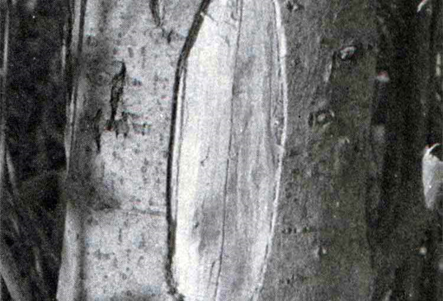

Figure 2: Bark Tracing to remove split

A tree growing with good vigor usually calluses over quickest. Encourage vigor in the tree with yearly spring fertilizer applications -- and be sure to provide adequate irrigation in hot, dry weather. Bark splits will often close over completely leaving a slight ridge in the trunk where callus tissue has been produced.

**Updated by** SLJ2 and LG658 2024

**READ THE LABEL BEFORE APPLYING ANY PESTICIDE!** Changes in pesticide regulations occur constantly. All pesticides distributed, sold, and/or applied in New York State must be registered with the New York State Department of Environmental Conservation (DEC). Questions concerning the legality and/or registration status for pesticide use in New York State should be directed to the appropriate Cornell Cooperative Extension Specialist or your regional DEC office.

**The Cornell Plant Disease Diagnostic Clinic**

Phone: 607‐255‐7850; Fax: 607‐255‐4471

Email: [Cornell-plantdiseaseclinic@cornell.edu](mailto:Cornell-plantdiseaseclinic@cornell.edu)

Web: plantclinic.cornell.edu