

Plant Disease Diagnostic Clinic

Plant Pathology and Plant-Microbe Biology Section  
329 Plant Science Building Ithaca, NY 14853‐5904

**Botrytis Blight:** *Botrytis cinerea; Botrytis* spp*.*

**Introduction**

Botrytis blight or gray mold is a fungus disease that infects a wide array of herbaceous annual and perennial plants. Several species of the fungus Botrytis can cause blights; the most common is Botrytis cinerea. Botrytis infections are favored by cool, rainy spring and summer weather usually around 15°C (60°F). Gray mold can be particularly damaging when rainy, drizzly weather continues over several days.

*Botrytis cinerea* can infect many ornamental plants including: anemone, begonia, calendula, chrysanthemum, dahlia, dogwood, fuchsia, geranium, hawthorn, heather, hydrangea, marigold, pansy, periwinkle, petunia, rose, snapdragon, sunflower, sweet pea, violet, zinnia. Two other damaging Botrytis blight fungi have strict host preferences: *B. paeoniae* infects peonies, and *B. tulipae* infects tulips causing the disease known as tulip fire.

Figure 1: Rose affected by botrytis blight. (provided by the Plant Disease Diagnostic Clinic, Cornell University)

Among vegetables and fruit, *B. cinerea* can infect asparagus, bean, beet, carrot, celery, chicory, crucifers, cucurbits, eggplant, endive, grape, lettuce, onion, pepper, potato, raspberry, rhubarb, rutabaga, shallot, strawberry, tomato, turnip, and others. Refer to Table 1 for further details on how botrytis blight affects certain kinds of plants.

**Symptoms and Signs**

During wet or humid weather, examine any brown or spotted plant material that develops, and look for masses of silver-gray spores on the dead or dying tissue. These spores are readily liberated and may appear as dust coming off from heavily infected plant material. Some species of Botrytis form tiny black resting structures called sclerotia that may be evident on dead plant tissue in late summer. Not all species of Botrytis readily form these, so they may not be observed on all plants.

**Disease Cycle**

Botrytis blight can affect leaves, stems, crowns, flowers, flower buds, seeds, seedlings, bulbs, and just about any other part of a plant apart from the roots. Fortunately, this fungus usually prefers certain plant parts on each kind of plant it attacks as outlined in Table 1.

On most susceptible plants, new infections may begin in the spring as soon as weather conditions are favorable for disease development. Wet or very humid weather may be highly favorable for the spread of the disease. For some Botrytis spp., sclerotia develops in dead plant tissue and forms the overwintering stage of the fungus. Fungal mycelium may also overwinter in woody stem debris. Sclerotia germinates in the spring, or if mycelium grows out of infected debris, and conidia (infectious spores) develop. Conidia may be windborne or rain-splashed to cause new infections on susceptible host tissue.

**Management Strategies**

The best way to manage this disease is by inspection and sanitation. While inspecting plants, carry a paper bag for sanitation. Remove faded or blighted flowers, blighted leaves, or entire plants infected at the base and place them in the paper bag so they may be discarded with the trash or burned. It is best not to do any sanitation when plants are wet with dew or rain since this could spread fungal spores during conditions that favor infection. Likewise avoid overhead watering, syringing, or misting plants especially if Botrytis blight has been troublesome in the past. To promote rapid drying of plants, space them to allow good air circulation.

Remember that this fungus can overwinter as tiny, black sclerotia embedded in dead plant tissue. Therefore, practice sanitation every autumn. Remove plant debris from the garden, cut stalks at or below the ground level, and destroy or discard this plant debris.

Fungicide sprays may also help by protecting plants from infections. Apply these when spring weather is continuously cool and wet or if Botrytis blight has been a problem the previous year. There are many effective fungicides for use against Botrytis spp. in New York State, but products vary greatly depending on the site and type of plant(s) to be treated. Each fungicide is registered for use on different plant(s) or groups of plants so be certain the plant(s) which will be treated are listed on the label. Some fungicides with the active ingredients chlorothalonil, neem oil, *Bacillus subtilis*, or potassium bicarbonate may be registered to treat some plants in the home landscape. Some of those products are also registered to treat plants in the home orchard or vegetable garden. The label contains information on how to apply the fungicide as well as any precautions so follow the label instructions for all pesticides used.

For commercial applications, please refer to the appropriate commercial pest management guidelines, or contact your local Cooperative Extension Office for more information on currently registered products.

When Botrytis blight of peony is a problem avoid the use of dense, wet mulches and apply the first fungicide spray in early spring just as the red shoots begin to push up out of the ground. When tulip fire is a problem cut and remove fading flowers before petal fall and cut and remove foliage at ground level when it yellows. Apply the first fungicide spray when leaves are four inches high.

With continuous inspection and careful sanitation gray mold can be effectively managed. Keep an eye out for the silvery-gray mold and/or tiny black sclerotia which are sure signs of this disease.

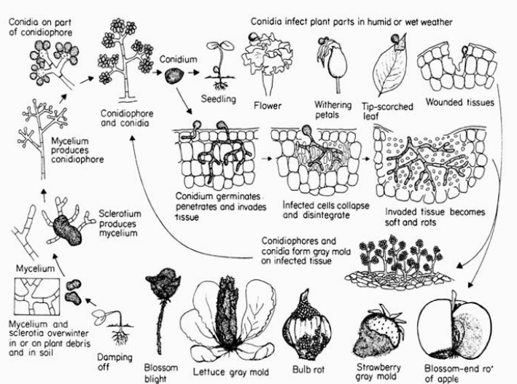

Development of Botrytis gray mold diseases.

(provided by George Agrios, Plant Pathology 4th Edition)

**Updated by** SLJ2 & LG658, November 2024

**READ THE LABEL BEFORE APPLYING ANY PESTICIDE!** Changes in pesticide regulations occur constantly. All pesticides distributed, sold, and/or applied in New York State must be registered with the New York State Department of Environmental Conservation (DEC). Questions concerning the legality and/or registration status for pesticide use in New York State should be directed to the appropriate Cornell Cooperative Extension Specialist or your regional DEC office.

**The Cornell Plant Disease Diagnostic Clinic**

Phone: 607‐255‐7850; Fax: 607‐255‐4471

Email: [Cornell-plantdiseaseclinic@cornell.edu](mailto:Cornell-plantdiseaseclinic@cornell.edu),

Web: plantclinic.cornell.edu