

Plant Disease Diagnostic Clinic

Plant Pathology and Plant-Microbe Biology Section  
329 Plant Science Building Ithaca, NY 14853‐5904

**Chestnut Blight:** *Cryphonectria parasitica*

**Introduction**

Chestnut blight is caused by the fungus *Cryphonectria parasitica* and infects American chestnut trees (*Castanea dentata*) throughout the United States and Canada. Once a major tree species, American chestnut trees filled Eastern and Midwestern forests. The fungus arrived from Asia with the import of Japanese chestnut trees in the late 19th century. By 1913, the disease had wiped out enough trees to warrant investigation by the USDA.

It was during this initial investigation that scientists discovered that Japanese and Chinese varieties of chestnut showed some resistance to the fungus. Although they showed signs of infection, the tree’s own defenses kept the disease from becoming fatal. This is likewise the case with many of the hybrid species that have recently been developed.

Unfortunately, the American chestnut was not resistant and by 1940, over three and a half billion trees had been lost to the disease. The species continues to survive by pushing up sprouts from the root systems as root and root collar tissue may be unaffected by the fungus. Although sprouts growing from roots in the forest under-story may survive until they reach a few inches in diameter, most are overcome by the blight before they become mature enough to produce nuts.

**Symptoms and Signs**

The chestnut blight fungus causes cankers, dieback, and ultimately death of aboveground parts of American Chestnut. Formation of cankers and death of the branches or stems may occur in a single season.

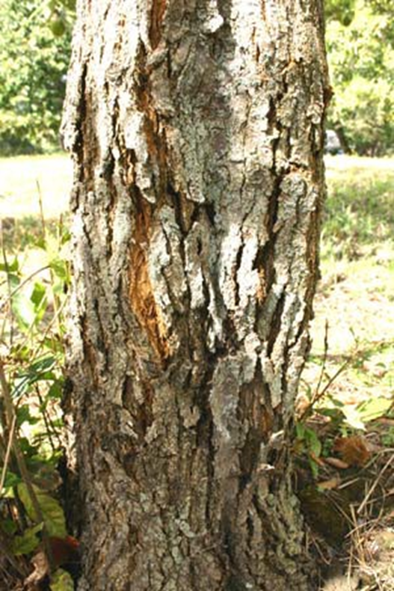

Figure 1: A developing canker causing the bark on the trunk to crack (provided by Gerhard W. Weber)

The disease first becomes apparent as cankers develop on stems of any size. Cankers expand laterally and may appear brown compared to healthy bark. Cankers may differ in appearance on different chestnut species, i.e. their appearance on rough-barked specimens (Fig. 1) may vary from their appearance on the smooth-barked American Chestnut. Additional diagnostic characteristics include the development of orange spore tendrils (masses of conidia) protruding from fruiting bodies on the cankered tissue (Fig. 2).

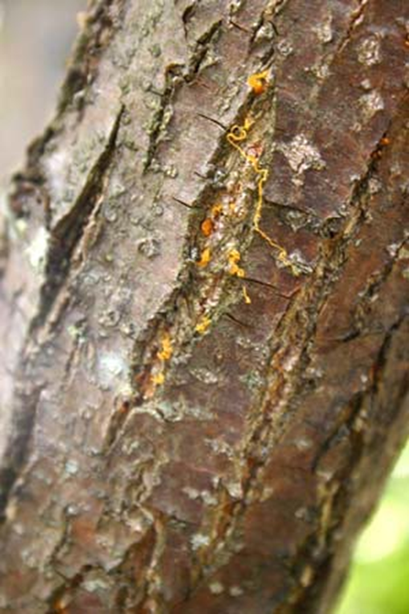

Figure 2: Yellow-orange tendrils composed of masses of conidia ooze from fruiting bodies developing on the canker (provided by Gerhard W. Weber)

**Disease Cycle**

The pathogen overwinters as mycelium in lesions and other colonized bark. In spring, fruiting bodies called pycnidia develop on the surface of the canker, and yellow-orange spore tendrils may be observed on the bark as they emerge from the yellow-brown pycnidia. Several weeks to a year later, darker fruiting bodies called perithecia also develop in the infected tissue and disperse a second type of spore, ascospores. Rain-splash and birds, insects, or animals may move the conidia, contaminate other bark elsewhere on the tree, or move conidia to additional trees. Ascospores are ejected from fruiting bodies so that they may become airborne and spread to new areas. Spore dispersal may continue through late autumn, and through the winter months if conditions are mild.

Most infections occur where spores germinate on and penetrate the bark, often through wounds made by insects. Within several weeks of the initial infection, the pycnidial stromata may develop and begin to produce conidia. The developing cankers cause the host tree to become water-stressed and further loose its ability to resist infection. Tissue above or beyond cankers is girdled and dies. Sprouts may begin to grow out of tissue just below the canker. Eventually, the cankers spread and girdle the tree, leaving just the root system alive. The fungus may also survive as a saprobe in killed chestnut tissues for at least two years.

Chestnut Blight can also occur on other *Castanea* spp. and may occasionally be found on trees grown for nut production in orchards. Although these trees may not be killed by the fungus, decline or death of limbs, and cankers on stems may weaken trees severely, preventing them from being fully productive. Additional chestnut species and some oak species may also sustain minor infections and serve as a source for the fungus.

**Research**

Two strategies of restoring the American chestnut are underway using hypovirulence and hybridization. Hypovirulence is a biological control using a viral disease that slows the progression of the canker. This allows the trees to outgrow the cankers and potentially build some resistance against it. The limiting factor in this method is the fast rate at which the fungus spreads, as opposed to the relatively slow spread of hypovirulence.

A second method called backcrossing is underway at the Connecticut Agricultural Experiment Station with the American Chestnut Foundation. Researchers are attempting to cross resistant varieties of Japanese and Chinese chestnut trees with the susceptible American trees. By repeatedly “back-crossing” these species a buildup of both American genes and resistant genes develops. Though these trees may become infected with the fungus, they develop the ability to resist the disease.

**Management Strategies**

Where orchard trees show symptoms of a Chestnut Blight infection, removal of the infected limbs, or of trees exhibiting trunk infections, may be the best method of preventing the spread of the fungus. Any limbs that become very weak or die should be pruned off and destroyed.

If limbs or stems show only minor evidence of infection and limbs still appear to be generally healthy, some success may be found in packing the injured areas with a minimally porous substance such as wet clay. **Please note**: This is not intended to cure the tree, only to minimize invasion of the wounds and/or prevent additional drying and dieback of affected tissues. However, do not wrap mud or any other substance around the circumference of the limb or stem as it may smother the bark. Use just enough material to cover any visible canker.

**References**

Diseases of Trees and Shrubs, 2nd ed. W.A. Sinclair and H.H. Lyon, Cornell University Press. http://www.kychestnut.org/mudpackingCankers.php

Chestnuts and the Introduction of Chestnut Blight by Dr. Sandra L. Anagnostakis http://www.ct.gov/caes/cwp/view.asp? a=2815&q=376754.

Chestnut Blight by Jim Worral. http:// www.forestpathology.org/dis_chestnut.html.

**Prepared by** N. Barbara Conolly December 2007; Updated by SLJ2 & LG658 December, 2024

**READ THE LABEL BEFORE APPLYING ANY PESTICIDE!** Changes in pesticide regulations occur constantly. All pesticides distributed, sold, and/or applied in New York State must be registered with the New York State Department of Environmental Conservation (DEC). Questions concerning the legality and/or registration status for pesticide use in New York State should be directed to the appropriate Cornell Cooperative Extension Specialist or your regional DEC office.

**The Cornell Plant Disease Diagnostic Clinic**

Phone: 607‐255‐7850; Fax: 607‐255‐4471

Email: [Cornell-plantdiseaseclinic@cornell.edu](mailto:Cornell-plantdiseaseclinic@cornell.edu),

Web: plantclinic.cornell.edu