

Plant Disease Diagnostic Clinic

Plant Pathology and Plant-Microbe Biology Section  
329 Plant Science Building Ithaca, NY 14853‐5904

**Common Cultural Problems of Landscape Trees & Shrubs**

**Introduction**

Trees and shrubs bring beauty to home landscapes, but sometimes common cultural practices can have adverse effects on the health of the plants. Use of lawn mowers, sprinkler systems, fertilizers, and mulch, practices that are supposed to keep one’s garden and lawn green, can cause great problems for the home garden if not used properly. This fact sheet is designed to help the average home gardener understand how to identify the symptoms of improper garden care and take the necessary measures to maintain trees and shrubs that are healthy and green.

**Symptoms and Signs**

**Mechanical Damage**

Lawnmowers and edge-trimmers are supposed to help keep a lawn and garden looking crisp and clean; however, the trunks of trees and shrubs are easy targets of careless use of these machines. Chipped bark exposes vascular tissue to the elements, providing an easy entry for bacteria, fungi, and pests to enter and infest a plant. Trees and shrubs are most susceptible to serious injury and disease during the spring when leaves are emerging and the bark is not fully developed after winter dormancy, as well as during fall leaf drop. Bark splitting is caused by wounds from pruning, insects, mechanical damage from lawnmowers, and weed whackers or planting too deep. Decline or dieback may also occur from trunk damage; fungi, bacteria, and insects can cause the breakdown of tissue around and inside the wound, causing structural problems for the root buttresses and lower trunk area.

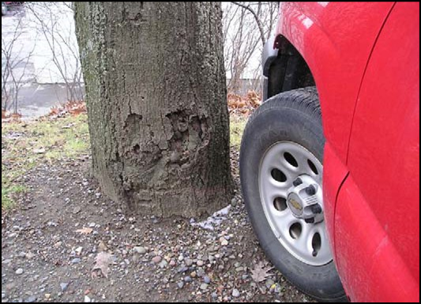

Figure 1: Car Bumper Damage (provided by Stephanie E. Whitehouse, Cornell University.

**Pesticide and Fertilizer Damage**

Some home gardeners may feel that pesticides and fertilizers are the “cure-all” for a plant that is under-performing; however, this is not always the case because the plant may or may not be experiencing an insect infestation or nutrient deficiency. Applying unnecessary amounts of fertilizer, no matter how large or small the dosage, can lead to excessive growth where shoots become leggy; this may also lead to increased pest problems as some pests prefer the succulent growth initiated by excessive fertilization.

Pollution of the garden or to runoff water may also occur, and over-application is a general waste of money and time. Choosing the wrong pesticide or fertilizer and/or applying it at inappropriate times during the year may also result in injury to the shrub or tree; i.e. a late summer application of fertilizer may cause a flush of growth that fails to harden off properly increasing the risk of cold injury.

Leaf burn is an easy indicator of over-application of a pesticide or fertilizer but may take a while to appear based upon the number of applications and the length of time between applications. Leaves may appear speckled with light green to white colored spots or blotches, indicating where the fertilizer or pesticide was sprayed. Injury from fertilizer applications made to the soil may appear in the veins and along leaf margins. Both symptoms are known to have greater effects on tissue that was not fully developed at the time of application. Distortion and stunting of new growth may also occur, tips of distorted leaves may be chlorotic or necrotic, and internodes may be shortened.

Once symptoms of phytotoxicity occur there is little chance that they will disappear until new growth replaces necrotic leaves. Some young plants may out-grow the damages, but distorted branches will never return to their healthy state. It is important to note that symptoms of dieback and inadequate growth can also be due to nutrient problems, so judge the likely cause of the injury based on the time of season and plant history. In many trees and shrubs, dieback and slowing of growth is a completely normal response to the changing of the seasons as the plants begin to prepare for winter dormancy.

**Over/Under Watering**

Any gardener knows that plants require water to live, and the necessary amount of water needed varies a great deal between species and across sites. Appropriate drainage of water in a garden is important to allow roots plenty of oxygen and help prevent the development of root pathogens. During a hot dry summer, it may be necessary to water more often, but gardeners may make the mistake of overwatering or even underwatering their plants. Surprisingly, the symptoms of drought and flooding are often times the same.

Overwatering can cause dieback due to drowning of roots, encourage the growth of water-loving weeds, promote diseases caused by bacteria and fungi, and may encourage other pests such as slugs. Young shoots will begin to wilt as leaves change to yellow or a light shade of green. Leaves also show signs of curling and the entire plant may show signs of wilting. Dying leaves may remain green but become brittle as they dry out. Older leaves may turn yellow or brown and may drop prematurely. Underwatering, usually characterized by short and frequent, or too infrequent watering sessions, can lead to the development of shallow root systems.

**Improper Mulching and Toxic Mulch**

Applying mulch to shrubs, trees, and garden beds is a great way to suppress weeds and maintain soil moisture. However, improper spreading and use of toxic mulch can have detrimental effects on plant growth and promote an environment that encourages fungal growth and the spread of pathogens.

Figure. 2: Pathogen Infestation from Root Rot Caused by Improper Mulch Piling (provided by Stephanie E.

Whitehouse, Cornell University.)

Herbaceous and newly planted shrubs and trees are the most susceptible as their root systems may be underdeveloped or experiencing shock from recent transplanting. Mulch should not be touching the edge of the trunk; basal stem decay can easily develop where mulch retains moisture against the bark. Deep piling of mulch can also promote the growth of a shallow root system which anchors in the mulch instead of the soil. Excess mulch also may harbor voles and other pests.

Mulch that is improperly stored and given enough insufficient aeration may develop toxic liquids and gases. If toxic mulch is applied to areas around trees and shrubs, these plants can experience burn injury from these toxins. Symptoms may resemble those of improper fertilizer application, over/under watering, and poor drainage, but may appear quickly, often within 24 hours of the application of the mulch.

**Management Strategies**

**Mechanical Damage:**

Using caution by steering clear of the trunks of trees and edges of shrubs when mowing lawns or using line trimmers is the best way to prevent damage. Setting up an edge or barrier using low decorative fencing or stonework around garden areas will help keep equipment a safe distance away from plants. Proper use of mulch also helps as it prevents a need to get close to stems with equipment.

If damage to a tree or shrub has already occurred, you may use a knife to trim around the bruised and peeled bark. Curve the area so that moisture and nutrients have the ability to move over the wound easily. This technique is further described in our fact sheet Bark Splitting on Trees. The sooner the area is treated the more likely the wound will heal. If the tree is young, it may be able to grow around the wound.

**Note**: For large or valuable trees, it may be wise to hire an arborist to investigate the damage, trim the wound, and suggest further care instructions.

Figure. 3: Improper Mulch Application (provided by Stephanie E. Whitehouse, Cornell University).

**Pesticide and Fertilizer Damage:**

It is important to first know whether it is necessary to apply fertilizer. One quick way this can be determined is by analyzing the vigor of the plant. For trees, measure the annual growth from the terminal bud to the first ring of bud scale scars; for many trees, if the growth is longer than 6”, fertilization is not needed to promote growth. For a more qualitative approach, you may also have the soil tested, or if plants appear chlorotic, some labs also offer foliar nutrient analysis.

When purchasing plants, you may ask the garden center or nursery for a recommendation of the appropriate amount and type of fertilizer to use. Information about proper fertilizers and techniques for fertilizing trees and shrubs can be found in The Cornell Guide for Planting and Maintaining Trees and Shrubs. This resource is available for purchase or it may be viewed online. It provides additional information on site selection, planting techniques, etc. Additional resources for information on fertilizing trees and shrubs may be found at some local Cornell Cooperative Extension Offices.

**Over/Under Watering:**

Timing is a major factor in the watering of plants. Not only is it important to water in the early morninghours (before 10AM) to prevent leaf burning and discourage disease development, watering should only occur on days when significant rainfall is not expected and/or when the soil is nearly dry. Although automated sprinklers may be helpful in saving time, few systems can monitor and adjust to day-to-day weather changes. If a sprinkler system is programmed for a vacation, it may be advantageous to ask a neighbor to keep a watch on the garden and ask him/ her to turn off the system if rainfall is more frequent than expected.

Drainage of the garden soil is also a major factor in drought or flooding conditions. It is important to know the drainage ability of the area used for planting. Sandy soils drain quickly and thus may require more watering than usual. Clay soils, which are dense and difficult to break up and move when wet, retain water more easily and thus require less frequent watering. Clay soils also cause problems for lawns and areas of heavy rainfall; since water does not drain through the soil easily, the possibility of runoff and flooding is high. Sending a soil sample to a local university or garden center that will provide clay and sand content may also be helpful. If drainage is extremely poor, hiring a professional landscape contractor who is experienced in grading and drain tiling may be helpful.

**Toxic and Improper Mulching:**

Many times, the cause of improper mulching lies in not understanding exactly how deep and close to the plant to mulch. The depth should be 3-4 inches but should taper to the ground at the trunk. Leave about a 3-inch border between the mulch and the trunk. Extending mulch out about 3-6 feet from trunk covers and protects most of the root system.

Purchase mulch in a bag that has plenty of small holes for aeration and store in a dry location. Before applying, smell the mulch; it should have a freshly cut pine-like or cedar scent depending upon the type. If the mulch has a pungent vinegar or rotten egg smell, do not apply it. A simple solution to get rid of the toxic liquids and gases that have accumulated in the mulch, spread it out on a tarp that is placed far away from the trees, shrubs, and garden beds of interest. Exposing the mulch to air will help rid of the gases. Water the mulch to rid it of the toxic liquids, but make sure the weather is dry so that the mulch has a suitable environment for drying. Sadly, there are no chemical applications to detoxify sour mulch that has already been spread; the only solution is removal. Mulch that is not being used should be stored in long windrows and overturned frequently.

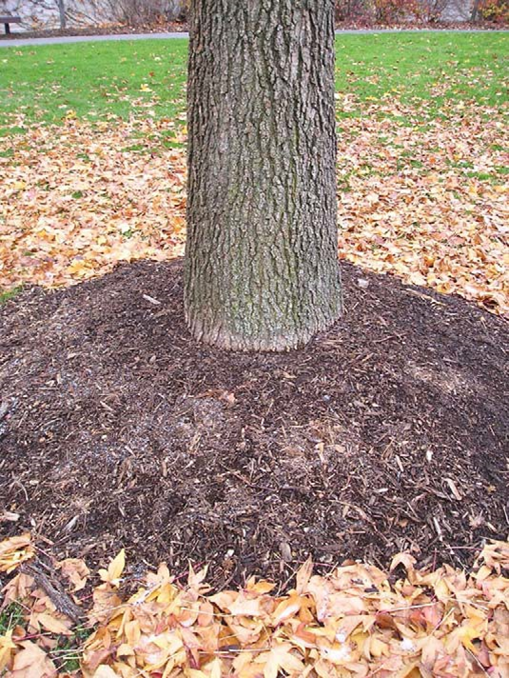

Figure. 4: Improper Mulch Application (provided by Stephanie E. Whitehouse, Cornell University.).

**References**

Appleton, B; Kauffman, K. “Selection and Use of Mulches and Landscape Fabrics.” Virginia Cooperative Extension. https:// pubs.ext.vt.edu/430/430-019/430-019.html 20 November, 2006.

“Cornell Gardening Resources: Beware of Toxic Mulch.” Cornell Cooperative Extension. http:// www.gardening.cornell.edu/factsheets/mulch/ toxicmulch.html, 8 November, 2010.

Appleton, B. “Selection and Use of Mulches and Landscape Fabrics.” http://pubs.ext.vt.edu/430/430- 019/430-019.html, 1 May, 2009.

Good, George L. and Richard Weir, III. 2005. Cornell University Cooperative Extension Bulletin 24, The Cornell Guide for Planting and Maintaining Trees and Shrubs, 28pp. http:// www.ecommons.cornell.edu/handle/1813/3572.

“Fertilizing Trees and Shrubs.” Cornell Cooperative Extension Chemung County. http:// www.ccechemung.org/wp-content/uploads/2013/09/ fertilizing-trees-shrubs.pdf.

**Prepared by** Stephanie E. Whitehouse, December 2006; Updated by SLJ2 & LG658 November 2024

**READ THE LABEL BEFORE APPLYING ANY PESTICIDE!** Changes in pesticide regulations occur constantly. All pesticides distributed, sold, and/or applied in New York State must be registered with the New York State Department of Environmental Conservation (DEC). Questions concerning the legality and/or registration status for pesticide use in New York State should be directed to the appropriate Cornell Cooperative Extension Specialist or your regional DEC office.

**The Cornell Plant Disease Diagnostic Clinic**

Phone: 607‐255‐7850; Fax: 607‐255‐4471

Email: [Cornell-plantdiseaseclinic@cornell.edu](mailto:Cornell-plantdiseaseclinic@cornell.edu),

Web: plantclinic.cornell.edu