

Plant Disease Diagnostic Clinic

Plant Pathology and Plant-Microbe Biology Section  
329 Plant Science Building Ithaca, NY 14853‐5904

**Maple Decline:** *Various factors*

**Introduction**

Maple decline affects primarily sugar maple (*Acer saccharum*), Norway maple (*A. platanoides*) and red maple (*A. rubrum*) in the Northeast. The problem is not a new one; stagheaded maples were described as early as 1917 in Massachusetts. At that time, dieback was attributed mainly to drought and to the poor conditions for tree growth afforded by the urban environment. However, reports of the incidence and severity of maple decline have increased markedly in recent decades and now include trees in urban, sugarbush, and forest environments.

In forests, maples usually begin to decline after several successive years of defoliation by insects. Affected trees not only lose their first set of leaves to these insects but will often use up valuable food reserves to produce a second set. During and after "refoliation", chemical changes occur in the tree that increase its susceptibility to secondary pathogens. *Armillaria* spp. (root rot), *Nectria cinnabarina* (branch canker) and *Steganosporium ovatum* (twig blight) are three fungi that frequently attack and may kill trees weakened by defoliation and refoliation.

In sugar-bushes, predisposing stresses include drought, heavy grazing, over-tapping, and/or heavy traffic by farm machinery. Severely affected trees are often over-mature and may have been heavily tapped for many years. Tapping holes, animal-damaged roots, and machine-damaged roots are all points of entry of wood decay organisms. If this scenario is followed by insect defoliation as previously described, the result may be mortality of the stressed tree.

In urban sites principal stress factors in maple decline include drought, de-icing salts and/or road and sidewalk construction. These stresses also facilitate invasion by secondary organisms including root rots, decays and twig blights which greatly reduce chances of recovery from original stress(es).

No matter which of the three environments maple decline occurs in, the sequence of events is similar. Healthy trees are stressed repeatedly, the stresses alter the tree's internal chemistry to allow repeated attacks by secondary organisms, and the trees ultimately die.

Figure 1: Early symptoms of off-color foliage.

**Symptoms and Signs**

**Reduced twig growth.** Yearly twig growth varies considerably between trees and even within the canopies of individual trees. Progressively shorter twig growth over multiple years may be a sign of decline.

**Reduced foliage growth.** Keep in mind the normal, healthy appearance of a particular maple species' foliage. Foliage that is sparse, light green and/or scorched signals that the tree may be declining. Widespread scorching may also be due to water stress, exposure to de-icing salts, or infection by a bacterium*, Xylella fastidiosa*, the causal agent of Bacterial Leaf Scorch.

**Early fall coloration** (Fig. 1). Maples normally begin showing fall color after the first frost or in mid-to-late September. When fall color develops earlier than normal, in late July or early August, the maple may be suffering from decline. Where individual larger branches exhibit premature fall color, and leaves are noted to be small, however, that may be evidence of Verticillium Wilt. Analysis of symptomatic branch tissue by a diagnostic lab may be required to confirm a Verticillium diagnosis. Verticillium can infect all species of maple as well as many additional trees and shrubs.

**Dead branches in upper canop**y (Fig. 2). Small dead branches seen in treetops in late spring or early summer are indicative of decline. Over time, larger, more visible branches and limbs will dieback. The more numerous the dead twigs or branches are, the more severe the decline condition.

Figure 2: Dieback in the upper crown with tufted foliage at the tips of the branches.

Again, this differs slightly from Verticillium Wilt where individual larger branches may die back (Fig. 3) while the rest of the crown appears normal. After several years losing one or more large branches to Verticillium however, infected trees may be weak enough to enter into decline (fig. 4).

**Poor root condition.** If roots can be examined, look for reduced occurrence of small feeder rootlets and/or brittle roots. Also, examine the lower stem and buttress roots for any evidence of wounding or decay. Wounds to buttress roots may open weak trees up to colonization by wood decay organisms.

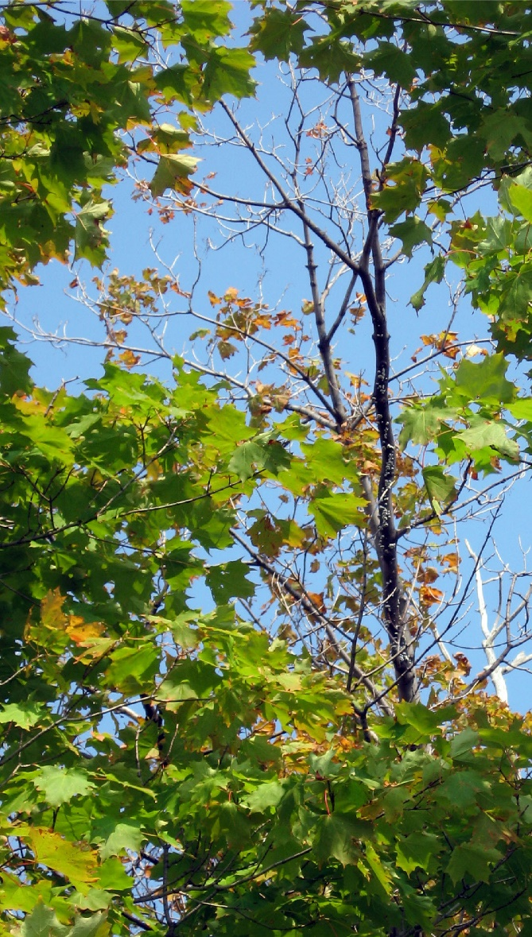

Figure 3: More typical symptom of Verticillium Wilt where individual branches flag and begin to die in early to mid-summer.

**Management Strategies**

By the time symptoms are noticed, the tree may be beyond being restored to its original splendor. Although once a tree is in decline, it may not be cured, providing good cultural care may help prolong the life of a declining maple. Keep in mind that these practices are to prolong the life of trees not already in a severe state of decline and may allow an opportunity for another tree to be planted which will eventually replace the declining maple. In this way, the newly planted tree will have a few years to grow prior to the removal of the declining maple. Plant young maple trees away from roads to avoid future de-icing salt problems. (If Verticillium is also confirmed, do not replant another maple in the same location or in close proximity to an infected tree.)

First be certain to provide adequate water during dry periods, this means you may need to thoroughly water trees every one or two weeks during extended periods of dry weather. Trees can be watered with a slow stream from a hose or using drip irrigation. You may want to avoid using a sprinkler if it will wet the bark or exposed buttress roots as that may encourage decay. Move the hose periodically to soak the soil in the area under the tree's branches to a depth of about six inches.

Provide adequate nutrition. There are a couple of options. You can have a soil test done to determine the optimum rate and type of fertilizer to use, or you can fertilize trees with a complete fertilizer in the spring and/or late fall. The general recommendation is 2 to 4 lbs. of fertilizer per inch of tree diameter (0.35 to 0.7 kg per cm of tree diameter at 1.5 m above ground). Broadcast the fertilizer over the root zone but note that fertilizer burn of nearby turf may occur at higher rates.

Remove dead wood. Proper pruning to remove larger dead branches in the crown may promote increased vigor in the remaining growth. This may also lower the hazard potential should a large dead branch fail. Pruning is best done in the early spring, before bud break, to promote healing of the pruning cuts. For large specimens, major pruning may require hiring a licensed professional with the proper equipment to do the job.

Protect the tree from de-icing salt. The impact of exposure to salt used on roads can be reduced by the use of a barrier (curb, berm, ditch, etc.) which will catch and/or divert the spring runoff water that may contain copious amounts of salt. If soil and foliar analyses have been run and high sodium or chloride concentrations were found, then leaching the soil with fresh water in the spring. Applying gypsum can help to improve the soil structure. Gypsum provides calcium that binds to soil particles, replacing sodium; this allows the sodium to be more readily leached from the soil.

Figure 4: After several years of dieback, it may be difficult to distinguish Maple Decline from Verticillium Wilt.

As defoliation can be a triggering factor in decline, pay close attention to developing insect issues on your trees. Although forest tent caterpillar populations may not be high every year, severe defoliation by these or other pests may trigger decline or result in the death of an already weakened tree. In years when pest issues may be high, an insecticide treatment may help to protect your tree(s). Be sure to properly identify insect pests to determine the best treatment options.

The success of treating declining maples depends primarily on early detection of maple decline, the health of the tree prior to treatment, and/or its ability to respond to treatment. Positive diagnosis will often depend on "on the spot" examination or the amount of information obtainable from the person submitting a sample. However, the prescribed treatments of fertilizing, watering, and pruning will not damage healthy trees and may also be beneficial to trees suffering from other issues such as Verticillium Wilt.

**References:**

*Recognizing and Preventing Maple Decline*, James W. Walters, North Central Experiment Station: Northern Hardwood Notes 7.02.

Sinclair, Wayne A. and Howard H. Lyon. 2005. Diseases of Trees and Shrubs, 2nd ed. 660 pages Comstock Pub. Associates.

*Sugar Maple Decline: An Evaluation*, by Arthur H. Westing, Economic Botany. vol. 20, no. 2, April-Jun., 1966, pp. 196-212.

**Prepared by** KLS August 1999;Updated by SLJ2 & LG658, December 2024

**READ THE LABEL BEFORE APPLYING ANY PESTICIDE!** Changes in pesticide regulations occur constantly. All pesticides distributed, sold, and/or applied in New York State must be registered with the New York State Department of Environmental Conservation (DEC). Questions concerning the legality and/or registration status for pesticide use in New York State should be directed to the appropriate Cornell Cooperative Extension Specialist or your regional DEC office.

**The Cornell Plant Disease Diagnostic Clinic**

Phone: 607‐255‐7850; Fax: 607‐255‐4471

Email: [Cornell-plantdiseaseclinic@cornell.edu](mailto:Cornell-plantdiseaseclinic@cornell.edu)

Web: plantclinic.cornell.edu