

Plant Disease Diagnostic Clinic

Plant Pathology and Plant-Microbe Biology Section  
329 Plant Science Building Ithaca, NY 14853‐5904

**Nematodes:** Plant Parasitic, various

**Introduction**

Living in the cold Northeastern U.S. we are fortunate to have fewer plant parasitic nematode problems than those living further south. Still, some Northerners who grow plants outdoors do have problems with nematodes. Many annual ornamentals are at risk if planted in soil heavily infested with nematodes. They may develop serious root problems, grow poorly, and fail. There presently are no nematode "cures", but proper planning prior to establishment of plants and the care given to them after planting can have a substantial effect on their performance.

The nematodes discussed here fall into two groups, nematodes that spend their life cycle in the soil and roots of plants and those that spend at least part of their time feeding on the foliage of plants. Of the soil types, the most common is the root knot nematode, Meloidogyne spp. Root-knot nematodes have a broad host range of more than 200 reported plants. Other commonly found root-feeding nematodes include Stunt (*Tylenchorhynchus* spp.), Lance (*Hoplolaimus* spp.), Spiral (*Helicotylenchus* spp.), Lesion (*Pratylenchus* spp.), Cyst (*Heterodera* spp.), and Ring (*Criconema* spp.). Most foliar nematodes belong to the genera *Aphelenchus* or *Aphelenchoides*. The Pine Wood nematode (*Bursaphelenchus xylophilus)* is unique as it attacks mainly Japanese Black Pine trees and harms the tree by plugging up the sieve tubes of the tree's vascular system.

**Symptoms and Signs**

Symptoms may vary based on the plant part(s) attacked, species of nematode(s) present, and other pests or stress factors affecting the plant.

**Above Ground Symptoms**

Nematodes that feed on the roots cause above-ground symptoms similar to those resulting from many kinds of root injury. Foliage loses its luster and wilts. Prolonged root stress caused by nematodes may result in yellowing and eventual loss of foliage. New flushes of growth are stunted and weak, with fewer and smaller leaves than healthy plants. Plants tend to wilt more readily during low water or drought conditions than non-infested plants. The damage is usually distributed irregularly since nematodes are rarely distributed evenly in the soil.

Figure 1: Characteristic angled foliar lesions (provided by the Plant Disease Diagnostic Clinic, Cornell University).

Nematodes that feed on the foliage produce characteristic angled lesions on broad-leaved plants (Fig.1). Infections on narrowed-leaved plants can be misleading due to the small, strap-like leaves lacking the characteristic angular lesions. Instead, random leaves may turn completely brown and die (Fig. 2).

Figure 2: Damage on strap-like leaves (provided by Karen L Snover-Clift, Cornell University).

**Root Symptoms**

Root symptoms vary widely. Some kinds of nematodes cause tissues on which they feed to grow strangely (root-knot and some foliar nematodes, for instance); some stop the growth of the roots; others kill the cells on which they feed as they move through the roots (Fig. 3), leaving patches of dead tissue as they move on. Depending on the kinds of nematodes involved, damage may include galls, stunting, and decay of roots; infested roots are often darker in color than healthy roots. Fungi and bacteria that cause root rots, wilt, and other plant diseases often infect nematode-damaged roots earlier and more severely than uninjured roots. Some viruses can also be transmitted by nematodes.

Figure 3: Vermiform plant parasitic nematodes within root tissue (provided by Dr. Eric B. Nelson, Cornell University).

Among the dozens of nematode species associated with landscape ornamentals, only a couple seem to cause most of the serious problems. The root-knot nematodes (Meloidogyne spp.) are by far the most important. Their easily recognized galls in the roots make their presence easy to detect (Fig. 4). Galls result from the growth of plant tissues around juvenile nematodes which feed near the center of the root. Root-knot gall tissue is from without a hollow center, and is an integral part of the root, removing a root knot gall from a root tears root tissue. Nodules formed on the roots of many legumes because of beneficial Rhizobium spp. (nitrogen-fixing bacteria) and most other natural nodules or bumps are loosely attached to the root and have hollow centers. Active Rhizobium nodules have a milky fluid in the center.

Figure 4: Root knot nematodes cause symptoms of galling in the root system (provided by the Plant Disease Diagnostic Clinic, Cornell University).

**Laboratory Soil Sample Analysis**

Laboratory soil sample analysis or foliar analysis is the only way to detect the kinds of nematodes associated with a problem and may be necessary to identify the most effective control measures. Contact your local county extension agent for more information on nematode assays.

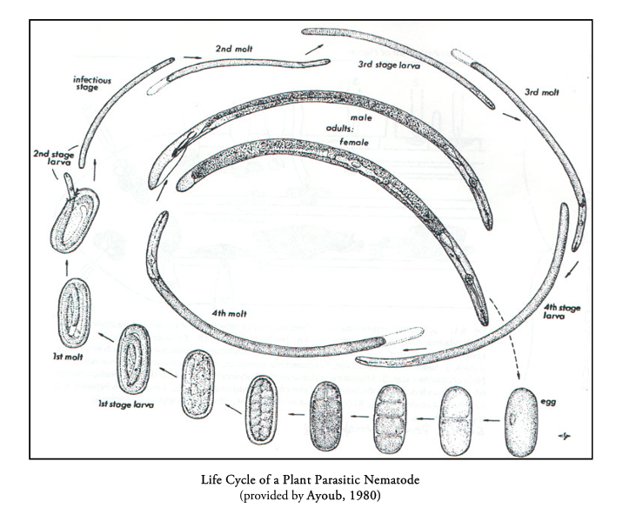**Disease Cycle**

Nematodes are microscopic, worm-like, animals with life cycles that include one egg stage, four juvenile stages, and one adult stage. Nematodes overwinter using several strategies: in the egg phase, within the dead female body, or in plant material. As the weather warms in the spring, the nematodes become active and begin feeding. Some female species become enlarged when they mature. They either produce and then deposit a mass of eggs outside of their bodies--as do female Root Knot nematodes, or they house the eggs within their bodies--as do female Cyst nematodes.

**Management Strategies**

In most cases, there are many attractive plants that could be planted on a site without serious damage or immediate losses. With proper care, an attractive landscape can be established and maintained, despite nematodes. The keys to minimizing the effects of nematodes on landscape ornamentals are good horticultural care and preventive maintenance as outlined below.

**Prepare new planting sites properly**

Give plants the best chance to become rapidly established. Native soil into which annuals are to be planted should be prepared well, including removal of any old roots, debris, etc., from the site. The water and nutrient holding capacity of the soil and activity of natural enemies of nematodes are improved by incorporating organic soil amendments into the soil before planting.

**Replace infested (contaminated) soil**

It may be simpler to remove all soil or planting mix from an annual bed and replace it with new nematode-free planting medium. Nematodes eventually will invade the new medium, and bedding plant roots can grow out of the new medium into the infested native soil, but infestation will be delayed and damage less severe.

**Use nematode-free stock**

No matter how perfect and pest-free the planting site, a nematode infestation already started in the roots of transplants will do the most damage. Buy only top-quality plants. Reject any that have clear evidence of nematodes or other problems.

**Select well-adapted plants**

Plant suitability to the location is important at all levels: region (climate), soil type, shade, drainage, etc. Plants that are "out of place" are more likely than well-adapted ones to suffer environmental stress. Moreover, a plant species that is "well adapted" to an area probably has some degree of tolerance or resistance to locally common pests, including some nematodes.

**Avoid nematode-susceptible plants**

Do not use plants that are very susceptible to nematodes known to occur in that planting site. Plants vary widely in their susceptibility to different nematodes, just as they vary in form, flower color, and season of bloom. Most references to "nematode susceptibility" in popular literature refer to one or more root-knot nematode species unless they specify others. Such lists are often incomplete, but it is quite likely that any plant identified as "nematode susceptible" should not be planted where root-knot nematodes are known to be serious. See **Table I** below for information on herbaceous plants and their observed response to specific nematodes.

**Keep other pests under practical control**

Stress from pests can set plants up for nematode infection just as readily as an over- or under-supply of nutrients or water. Overuse of pesticides can also injure plants, so use judgment in their application, and always follow the instructions on the pesticide label --- it's the law.

**Maintenance**

Give the plants optimum care from the start and for as long as you want them to perform well. Please note that "optimum" does not mean "maximum". Fertilize as needed to maintain healthy growth, not to produce excessive, succulent growth that invites attack by nematodes and other pests. Water deeply, to encourage development of a deep root system that can exploit a larger volume of soil for water and nutrients. Frequent shallow watering causes plants to develop a shallow root system. A large root system can better withstand a small amount of nematode damage without major compromise to the overall health of the plant than can a shallow, already minimal, root system.

**Do not allow maintenance to lapse**

Sudden dry periods or pest outbreaks can weaken plants in a very short time. Even under normal conditions, erratic or inadequate watering can weaken a plant so that it can no longer tolerate a modest nematode population that may have existed for years.

**Mulches**

Keep the plant root zone mulched to keep roots cool in hot weather and minimize evaporation of water from the soil surface. Organic mulches also contribute organic matter to the soil, thus enhancing the capacity of the soil to retain water and nutrients. Mulches reduce stress on the plant as a whole and on the root system specifically. Greater soil organic matter content also stimulates activity of natural enemies such as certain fungi, predatory nematodes, etc. which can help suppress nematode populations.

**Chemical controls**

Most chemicals that have historically been used for nematode control or suppression are highly toxic and have very limited uses, usually involving soil sterilization before planting. In addition, these chemicals have often been recommended only for crop production or other commercial uses and had few if any applications in landscape plantings. Currently, there are no traditional nematicides that may be used in the home garden, but there are some biological products containing neem oil or azadirachtin that are labeled to suppress listed nematodes. If used, be certain any product purchased is specifically labeled for this use and follow label directions.

**Table I** was compiled from various fact sheets and scientific articles. Bedding plants as well as vegetables and grasses are included. Plants listed were either not infested, lightly infested, resistant to, or actually suppressive of the various nematodes listed.

**References:**

Hagan, Austin et al. *Nematode Suppressive Crops*. 1994. Circular ANR-865. Alabama Extension Service.

Jones, R. K. *Nematode Management in Bedding Plants in the Landscape*. 1995. Plant Pathology Information Note. Ornamental No. 31. North Carolina Cooperative Extension Service.

Lehman, P. *Factors Influencing Nematode Control With Marigolds*. 1974. Nematology Circular No. 50. Florida Department of Agriculture and Consumer Services, Division of Plant Industry.

McSorley, R. and Frederick, J. *Response of Some Common Annual Bedding Plants to Tree Species of Meloidogyne.* 1994. Journal of Nematology. 26 (4S):773-777.

**Prepared by** clinic staff;Updated SLJ2 and LG658, December 2024

**READ THE LABEL BEFORE APPLYING ANY PESTICIDE!** Changes in pesticide regulations occur constantly. All pesticides distributed, sold, and/or applied in New York State must be registered with the New York State Department of Environmental Conservation (DEC). Questions concerning the legality and/or registration status for pesticide use in New York State should be directed to the appropriate Cornell Cooperative Extension Specialist or your regional DEC office.

**The Cornell Plant Disease Diagnostic Clinic**

Phone: 607‐255‐7850; Fax: 607‐255‐4471

Email: [Cornell-plantdiseaseclinic@cornell.edu](mailto:Cornell-plantdiseaseclinic@cornell.edu)

Web: plantclinic.cornell.edu